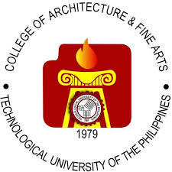**Republic of the Philippines**

**Technological University of the Philippines**

**College of Architecture and Fine Arts**



Name : **VASHTI KARMELLI V. CAMU**

Course : **BSCS-4B**

Subject : **GEE13-D READING VISUAL ARTS**

Instructor : **MARIA REGINA D. FREJAS**

Semester : **FIRST SEMESTER**

School Year : **2024-2025**

College Affiliated : **COS**

**TOPIC 1: World’s Visual Art & Culture**

1. **ASIA**

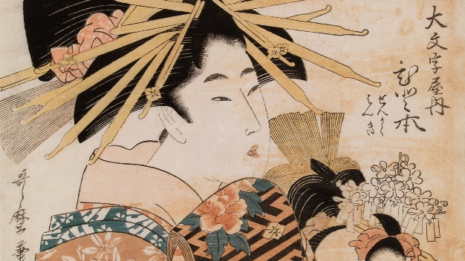 **JAPAN**

Renowned for its traditional arts like ukiyo-e woodblock prints, tea ceremonies, and contemporary art scenes in Tokyo. One of the most important genres of art of the Tokugawa period (1603–1867) in Japan. The style is a mixture of the realistic narrative of the emaki (“picture scrolls”) produced in the Kamakura period and the mature decorative style of the Momoyama and Tokugawa periods. The ukiyo-e style also has about it something of both native and foreign realism.

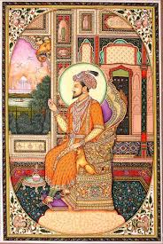

**INDIA**

Known for its diverse art forms, from ancient rock art and Indus Valley sculptures to Mughal miniatures and contemporary works, Indian art reflects the country’s complex history and cultural exchanges. Style of painting confined mainly to book illustration and the production of individual miniatures, that evolved in India during the reigns of the Mughal emperors (16th–18th century). In its initial phases it showed some indebtedness to the Ṣafavid school of Persian painting but rapidly moved away from Persian ideals. Probably the earliest example of Mughal painting is the illustrated folktale Tuti-nameh (“Tales of a Parrot”) at the Cleveland (Ohio) Museum of Assrt.

**CHINA**

Famous for its ancient calligraphy, porcelain, and contemporary art movements. Traditional Chinese calligraphy (shū fǎ) is very different from the calligraphy you see on wedding invitations. To start, the writing tools are different. Whereas Western calligraphy tools are usually ballpoint pens or markers, Chinese calligraphers use brush pens made from the finest animal hair.

1. **AFRICA**

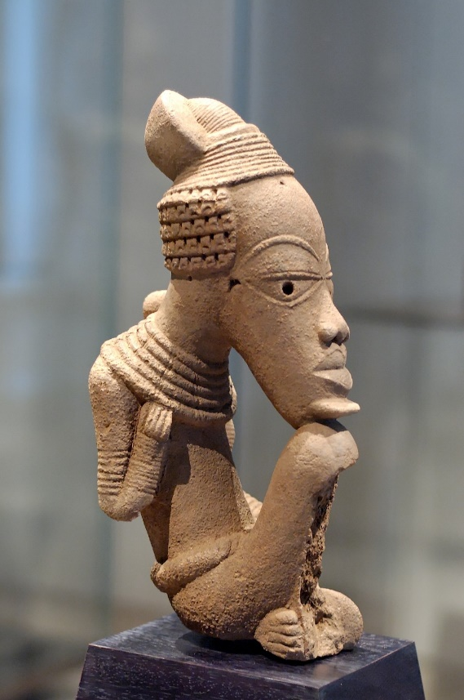 **NIGERIA**

Known for its vibrant traditional art forms, including Nok terracotta sculptures, Yoruba masks, and contemporary art scenes in cities like Lagos. The earliest-known sculpture of large size in the Sudan is the ceramic art of the Nok culture, which flourished extensively in northern Nigeria from the 5th century bce into the early centuries ce. These people were the first known manufacturers of iron in western Africa, furnaces at Taruga having been dated between the 5th and early 3rd century bce; they continued, however, to use stone tools. Their sculptures, of well-fired clay, represent animals naturalistically; human figures, however, are depicted with heads that are cylindrical, spherical, or conical. The subtractive technique used to create these objects suggests the presence of a significant woodcarving tradition. The art of Nok indicates the antiquity of many basic canons of West African sculpture, but the precise relationship between ancient and modern forms is obscure.

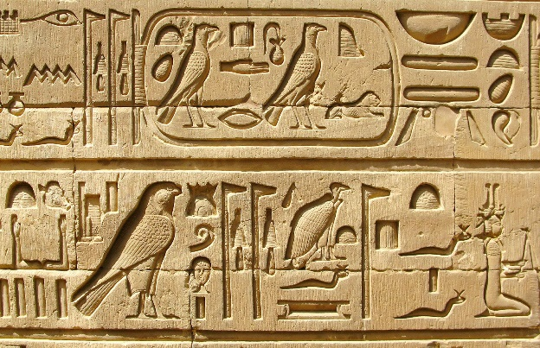**EGYPT**

Famous for its ancient art, including the pyramids, hieroglyphics, and the Sphinx. Contemporary Egyptian art continues to thrive, blending traditional influences with modern themes. Hieroglyphics, a feature that is quite remarkable about Egyptian art is that text was attached to almost all of the images produced. This is most notably seen in the statues and relief paintings created, as hieroglyphics were attached to these works. On the statues, identifying and explanatory text usually appeared on the back pillar or base that supported the work, while relief paintings and panels tended to have longer captions that explained and completed the stories in the scenes.

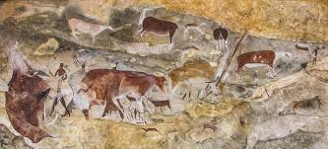**SOUTH AFRICA**

Home to diverse art forms, from ancient rock paintings by the San people to contemporary art showcased in places like the Zeitz MOCAA in Cape Town. Ancient drawings hidden away in caves and overhangs. This rock art depicts the San tribe's daily life, hunting, rituals, spiritual beliefs, and wildlife. These drawings offer a snapshot of what they experienced thousands of years ago, mostly long before the first Europeans arrived.

1. **ANTARTICA**

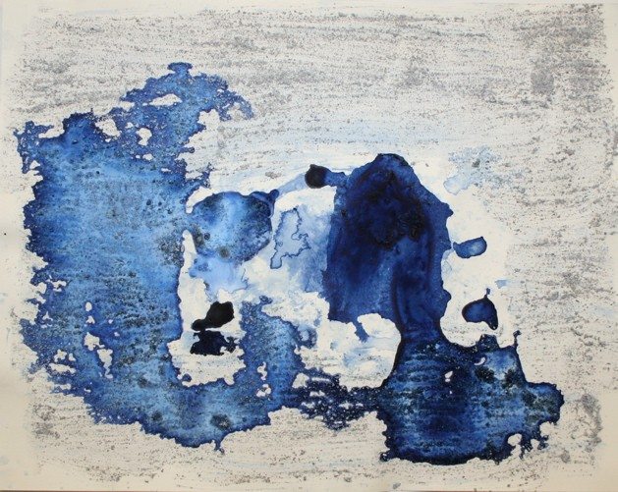

**ICE PAINTINGS**

Xavier Cortada, recipient of a 2006-2007 National Science Foundation Antarctic Artists and Writers fellowship, traveled to Antarctica to implement a series of projects and installations. While there, the Miami artist created “ice paintings” using sea ice and sediment samples provided to him by scientists working in Antarctica. The artist titled the works on paper by randomly selecting the names of geographic features from a map of the continent that inspired their creation.

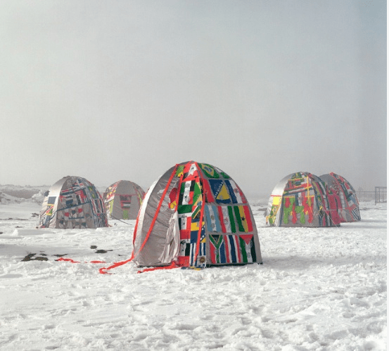

**ANTARCTIC VILLAGE**

In 2007, Studio Orta created "Antarctic Village," a collection of hand-stitched tent-like domes, in Antarctica to celebrate the Antarctic Treaty. This treaty protects the continent from militarization and industry. The Ortas later launched the "Antarctica World Passport Delivery Bureau," issuing symbolic passports to anyone who wants to be a citizen of Antarctica. This project has distributed over 55,000 passports worldwide. Studio Orta has now brought a retrospective of their Antarctica projects to New York City, showcasing their tent-sculptures and installations to a wider audience.

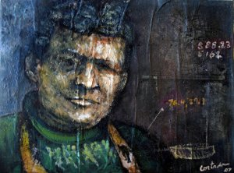

**SHACKLETON IN THE SOUTH POLE**

In 2007, artist Cortada created a portrait of Sir Ernest Shackleton, a famous Antarctic explorer. The portrait was made with materials from Antarctica, including soil, seawater, and crystals. Cortada presented the painting to the South Pole Station, symbolically placing Shackleton in the place he longed to reach. The artist hopes the portrait will inspire those working in Antarctica, especially those who winter over in the harsh conditions.

1. **EUROPE**

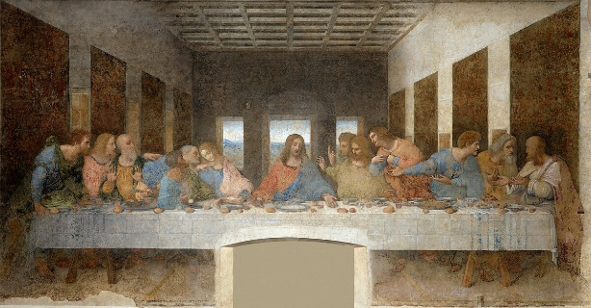

**ITALY**

Italy is home to some of the most iconic and influential artworks in history. Renowned for the cradle of the Renaissance, with masterpieces by artists like Leonardo da Vinci, Michelangelo, and Raphael. The Cenacle, also known as the Last Supper, is the most famous representation of Christ's last supper. It is a wall fresco, dating back to between 1494 and 1498, created by Leonardo da Vinci and commissioned by Ludovico il Moro, regent of the Duchy of Milan. The fresco is in the refectory of the Sanctuary of Santa Maria delle Grazie, in Milan.

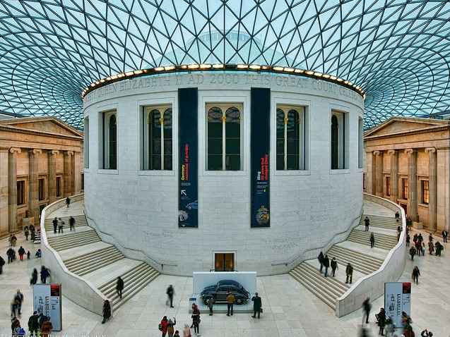**ENGLAND**

Known for its rich history in art, including the works of William Shakespeare, the British Museum, and contemporary art scenes in London. The British Museum’s artifacts, such as the Parthenon ‘Elgin’ Marbles and the Rosetta Stone, reflect England’s rich art culture and its history of collecting and preserving global art. This tradition is mirrored in England’s own artistic evolution, from medieval religious sculptures to the landscape paintings of J.M.W. Turner and John Constable, and contemporary works that explore social issues. The museum’s diverse collection highlights England’s significant role in the global art scene, making it a central piece of the country’s cultural heritage.

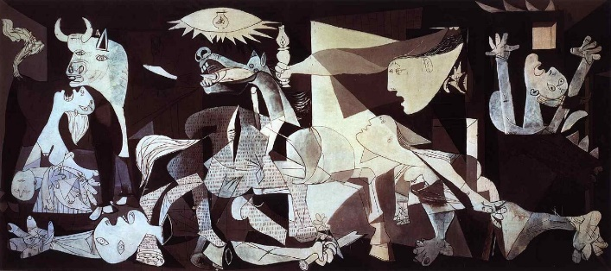

**SPAIN**

Known for its rich history in art, including museums are renowned for their exceptional collections and masterpieces, featuring artists like Goya, Dalí, and Picasso. The dance of Soul and Passion, Flamenco Tradition. Pablo Picasso**,** a name synonymous with innovation, shattered conventions with his Cubist visions. His “Guernica,” a poignant response to the bombing of a Basque town during the Spanish Civil War, remains one of art’s most powerful statements on the horrors of war.

1. **NORTH AMERICA**

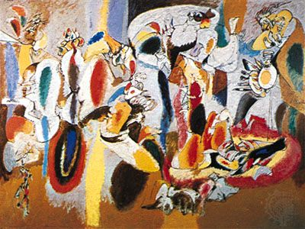

**UNITED STATES**

Diverse art scenes from Native American art to modern art movements like Abstract Expressionism. Abstract Expressionism, broad movement in American painting that began in the late 1940s and became a dominant trend in Western painting during the 1950s. The most prominent American Abstract Expressionist painters were Jackson Pollock, Willem de Kooning, Franz Kline, and Mark Rothko.

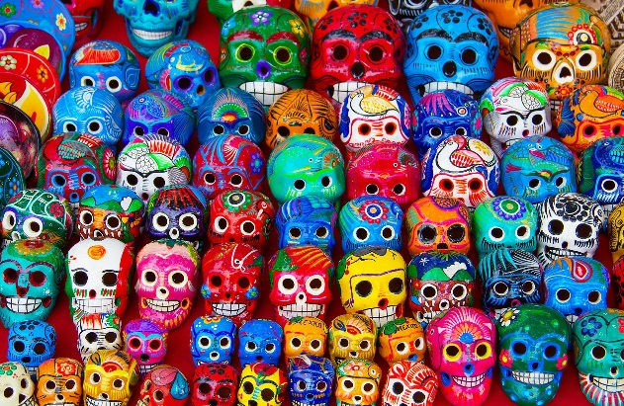**MEXICO**

Famous for its vibrant murals, folk art, and artists like Frida Kahlo and Diego Rivera. The post-Mexican Revolution government were the main driving factor behind the muralist movement as they used murals for political and propaganda reasons, they often would commission paintings with political messages with the hopes of reunifying the country through the power of self-expression and art. It was during this period that artists completely broke with European traditions, the leading artists to have been involved at the time were Diego Rivera, José Clemente Orozco and David Alfaro Siqueiros. Many of the paintings from these artists depicted vivid scenes of Mexican life as they believed that Mexican art should reflect Mexican culture and life.

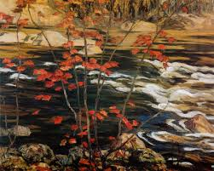**CANADA**

If there’s a defining style of Canadian visual art it’s probably the landscape. Canada’s exotic natural beauty was tremendously alluring to European artists in the 19th century. By the early 20th century depictions of the Canadian landscape gradually became more harsh and realistic, as Canadian-born artists sought to depict more accurate and varied scenes of nature. The most famous artists of this latter tradition were the so-called Group of Seven, seven artists who produced a number of great pseudo-impressionist works in the 1920s and 1930s.

1. **SOUTH AMERICA**

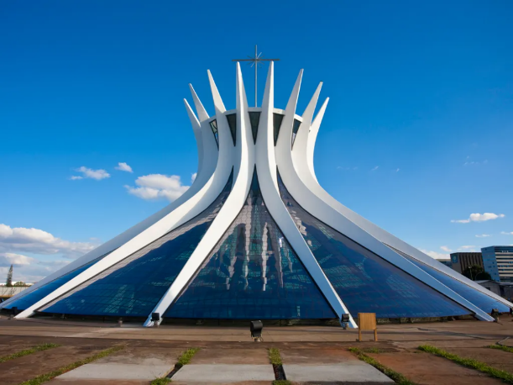 **BRAZIL**

Renowned for its colorful street art, Carnival, and modernist architecture by Oscar Niemeyer. Brazilian architect known for his significant contributions to modern architecture, Oscar Niemeyer. He is celebrated for his innovative use of abstract forms and curves, which are prominently featured in his designs for Brasília, the capital of Brazil. Niemeyer’s work includes iconic structures such as the National Congress of Brazil, the Cathedral of Brasília, and the United Nations headquarters in New York, which he co-designed.

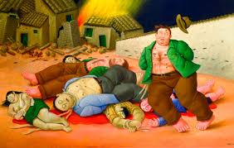**COLOMBIA**

Colombian art is a vibrant tapestry that reflects the country’s diverse history and cultural influences. From the intricate gold work of the Quimbaya civilization to contemporary pieces. Colombian art is also distinguished by its use of humor and satire. Artists often employ these devices as tools of political criticism or to offer a different perspective on personal history and societal norms. The whimsical nature of Botero’s “Boterismo,” with its plump and jovial figures, provides a platform for subtle social critique, highlighting issues within the Colombian society with both affectionate humor and sharp insight.

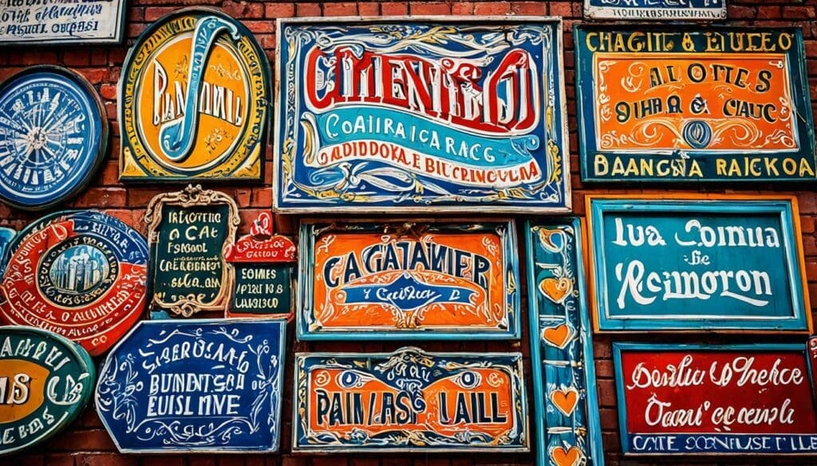**ARGENTINA**

Known for its tango music and dance, as well as contemporary art in Buenos Aires. Modern Argentine painting is characterized by its strong use of color and brushstrokes, as well as its focus on light and shadow. Fileteado is a form of decorative painting that originates from Buenos Aires, Argentina. The painting is characterized by its use of bold and intricate patterns, often with geometric shapes and bright colors. Fileteado paintings can be found on the sides of buildings, buses, and other public places in Buenos Aires.

1. **OCEANIA**

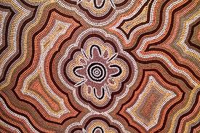 **AUSTRALIA**

Home to Aboriginal art, contemporary art scenes in Sydney and Melbourne, and the Sydney Opera House. Aboriginal art is a vibrant and significant cultural expression that encompasses a rich history and deep spiritual connection to the land. Originating from Indigenous Australian communities, this art form encompasses a diverse range of styles, techniques, and themes, reflecting the deep-rooted traditions, stories, and beliefs of the Aboriginal peoples. The term “Dreamtime” or “Dreaming” represents the Aboriginal understanding of the world, its creation, and its great stories. Aboriginal Art is a vehicle through which these Dreaming stories are expressed and preserved.

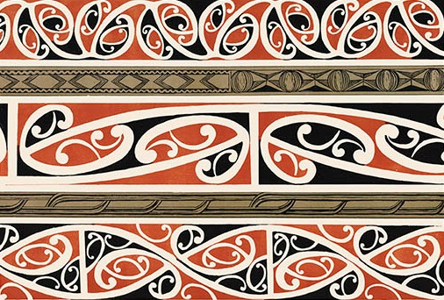

**NEW ZEALAND**

Known for Maori art, including carvings and tattoos, and contemporary art. Toi, or Māori art, centres around four primary art forms; raranga (weaving), whakairo (carving), tā moko (tattooing) and peitatanga (painting). Te Papa Tongarewa and the Auckland Museum both have impressive collections of traditional Māori arts and crafts.  The centuries old tradition of tāmoko (Māori tattoo) is an important custom that is still practiced today. Historically, these beautiful tattoos were a bit like a résumé, telling the wearer’s story through visual symbols. Today, the practice has evolved to be an expression of cultural pride and unity, often carried out to mark a significant occasion, such as university graduation or the passing of a family member. One thing that hasn’t changed though, is that to receive tāmoko is a great honor.

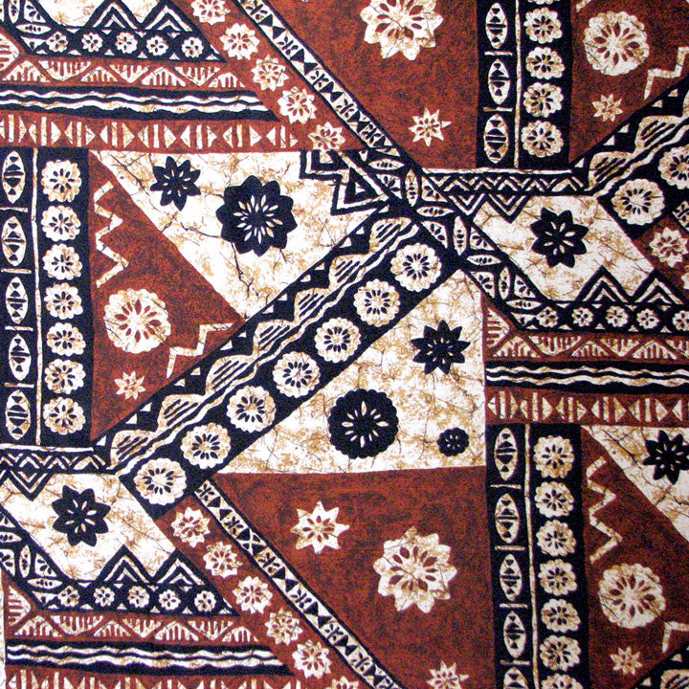

**FIJI**

Famous for its traditional crafts, including tapa cloth and wood carvings. Masi and tapa are names for bark cloth. This art form is practiced in many regions of the South Pacific and in several areas of Fiji. Masi has many uses, including as ceremonial dress, wall decorations and more recent innovations such as table mats and handbags. It also makes a fine souvenir for visitors.